ST. XAVIER’S COLLEGE

**Maitighar, Kathmandu**

**(Affiliated to Tribhuvan University)**



**Computer Graphics**

**Lab Assignment #4**

To trace a line segment using BLA

**Submitted By**

Alok Shrestha

B.Sc. CSIT

Year II/IV Semester

013BSCIT005

**Submitted To**

Er. Anil Sah

Lecturer

Department of Computer Science

St. Xavier’s College

Maitighar, Kathmandu

**Submitted On**

August 18, 2015

**STATEMENT**

**TO TRACE A LINE SEGMENT USING BLA**

**ALGORITHM**

1. Input the two line endpoint and store the left endpoint at (x0,y0)
2. Load (x0,y0) in to frame buffer, i.e. Plot the first point.
3. Calculate constants 2∆x, 2∆y calculating ∆x, ∆y and obtain first decision parameter value as   
   p0=2∆y - ∆x
4. At each xk along the line, starting at k=0, perform the following test,   
   If Pk< 0 then pixel to be plotted is (xk+1,yk) and

Pk+1=Pk+2Δy

If Pk>=0 then pixel to be plotted is (xk+1,yk+1) and

Pk+1=Pk+2Δy-2Δx

1. Repeat step 4 (previous one) Δx times

**SOURCE CODE**

//---------------------------------------------------------------------------

#include <vcl\vcl.h>

#pragma hdrstop

#include "Unit1.h"

//---------------------------------------------------------------------------

#pragma resource "*.dfm"

TForm1 *Form1;

int x1,x2,y1,y2;

//---------------------------------------------------------------------------

__fastcall TForm1::TForm1(TComponent* Owner)

: TForm(Owner)

{

}

//---------------------------------------------------------------------------

void __fastcall TForm1::Button1Click(TObject *Sender)

{

x1=StrToInt(Edit1->Text);

y1=StrToInt(Edit2->Text);

x2=StrToInt(Edit3->Text);

y2=StrToInt(Edit4->Text);

int x, y, dx, dy, pk, k, xEnd;

dx=abs(x2-x1);

dy=abs(y2-y1);

if(x1>x2)

{

x = x2;

y = y2;

xEnd = x1;

}

else

{

x = x1;

y = y1;

xEnd = x2;

}

Image1->Canvas->Pixels[x][y] = RGB(0,0,255);;

pk=2*dy-dx;

while (x<=xEnd)

{

if(pk<0)

{

x=x+1;

y=y;

pk=pk+2*dy;

}

else

{

x=x+1;

y=y+1;

pk= pk+2*dy-2*dx;

}

Image1->Canvas->Pixels[x][y] = RGB(0,0,255);

}

}

//---------------------------------------------------------------------------

**OUTPUT/s**

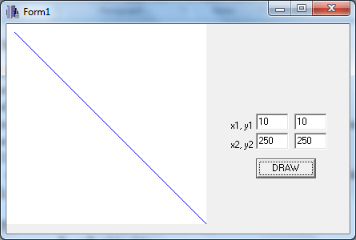

**CONCLUSION**

Hence, the given line was traced using BLA in C++builder.